Title: Using UML service components to represent the SOA architecture pattern
Author: Prithvi Rao
Article Summary:
This research paper by an IT architect Prithvi Rao explains the representation of SOA pattern with the use of UML service components. This paper is targeted to the IT architects in software industry who in their day to day routine has to deal with enterprise clients and other stakeholders for business applications. This study helps architects to make clients better understand the model of their software which will be developed. Service is the fundamental element and can be described through components and interfaces to provide functionality. Existing software can be re-used for developing new services through SOA approach. This is technical paper which highlights various services such as interaction, process, information, and partner etc. with the help of diagrams for mapping in with SOA. The key implication of this paper is to make architect clear the role of UML components so that business application and its functionality are revealed out to clients accurately in order to develop a desired software with its objective achieved.
Article Analysis:
The author styled out the complete services involved for SOA pattern representation with the use of UML services. High level of technical details are laid out in the study starting from the architecture to services and business level application information. Services explained by author in paper are described below:
SOA Architecture and Services:
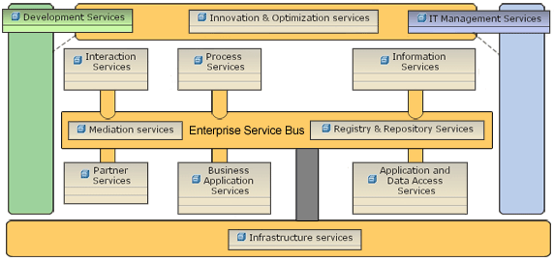
Fig. 1 Logical SOA reference architecture
- Enterprise Service Bus: It can be said as the central bus service which acts as a mediator between the requestor who needs some information and provider which contains information to exchange message. ESB provides a common means for connection and virtualization of services. ESB comprise of:
A. Communication protocol so that requestor and provider can interact.
B. Message models for supporting the content of message.
C. Mediation flows in order to process the requests initiated and provide output.
- Interaction Services: These serves as entry point for user and interacts with ESB as shown in Fig 1. And also serves as the presentation layer for SOA. Main parts are User interface services, user interaction services and deployment services. Provide interfaces for user to interact with websites, portal, applications or any other devices.
- Process Service: It includes logic to process the business flow, to make decisions and rules which are to be followed. This is done through a language known as BPEL.
- Information Service: As per paper and author’s description this is also one of the important service which deals with data management activities. The data available to user should have a common platform for describing models and understanding. Also the data transmission from one place to another is taken care of. Federation component is used in order to avail high access to data with secured accessibility and high performance. Data placement component are used for caching and replication. Search service is used to have common or relevant data at one place from the database which can be done by implementing query. Analytics component is used for predictions, structuring business application.
- Partner Services: This is used for business integration purpose with the use of adapters for connecting with SOA enterprise architecture. Paper presented this with clear diagram explanation. Adapters contains various API’s for communication with EIS. Additional tools are there for configuration.
- Business Application Services: They are used for business process and policy management. Security, Authority and decision making capabilities are handled by security governance framework. Trust management ensures trust maintained by the two communicating enterprises while doing transactions and exchanging information over secured network through cryptographic methods. There also exist service for identification and access management in order to provide access to authorized identified personnel’s. For secured communication over network firewalls, intrusion detection system exists in SOA. Risk management component measures the risk level. Enterprise communicating should maintain the agreed state and federal compliances.
- Application and data access services: Different technologies existing should be able to communicate within the SOA which required integration of services across various platforms and is achieved by application and data access services. For data accessibility relational database is used.

Article Critique:
This study of SOA patterns and service components provides in-depth information of service pattern. Based on my reading of this paper below are the strengths and weakness:
Strengths:
- Reader gets a thorough understanding of SOA approach and how it can be used for business applications and purposes.
- SOA provides business flexibility which is required in today’s competing world as it can be deployed through web services and different platforms are able to communicate through it.
- SOA includes several policies and rules which are mandatory in modern world life as many applications needs to be highly secured, trusted, data security, performance enabled. All this is provided by SOA approach.
- Existing applications can be integrated with SOA by identifying the accurate requirements and dissecting existing elements of application with skilled resources, in-depth technical groundwork. This also helps stakeholders by making in less investments and saving money.
- This paper will surely help architects and designer in their implementations and designing activities.
Weakness:
- This paper does not goes well with its title as the author has detailed the SOA architecture and pattern, but reader will not be able to understand how UML services are doing this. Author should have included a bit UML description of association or composition etc. relationships as seen in the diagrams in the article.
- Author should have felt the need to explain the UML structure implementing SOA.
- Lack of examples citation in the article was felt while reading. If some real-life example implementing SOA would have been presented, would make paper more successful in terms of reader for reading and having complete understanding.

